Incorporating machine learing algorithms to improve arrival time prediction accuracy based on history data traffic conditions

The ability to obtain accurate predictions of bus arrival time on a real- time basis is a vital element to both bus operations control and passenger information systems. Several studies had been devoted to this arrival time prediction problem; however, few resulted in completely satisfactory algorithms. This paper presents a new system that can be used to predict the expected bus arrival times at individual bus stops along a service route. The proposed prediction algorithm combines real-time location data from Global Positioning System receivers with average travel speeds of individual route segments, taking into account historical travel speed as well as temporal and spatial variations of traffic conditions. A geographic information system–based map-matching algorithm is used to project each received location onto the underlying transit network. The system is implemented as a finite state machine to ensure its regularity, stability, and robustness under a wide range of operating conditions. A case study on a real bus route is conducted to evaluate the performance of the pro- posed system in terms of prediction accuracy. The results indicate that the proposed system is capable of achieving satisfactory accuracy in pre- dicting bus arrival times and perfect performance in predicting travel direction.

Accurate prediction of the expected arrival time of the next bus at individual bus stops is of significant value to both transit operators and users. With this arrival time information, transit operators can promptly respond to unexpected service interruptions and delays by introducing various bus control strategies, such as holding and stop- skipping (1). In the long term, transit operators could spot problematic routes and shifts that chronically run late and promptly take man- agerial and technical actions—such as training operators, adjusting schedules, and implementing transit signal priority—for improved performance. The overall quality of transit service could therefore be improved, which would ultimately make the public transporta- tion mode more user-friendly and attractive as compared with other transportation modes such as driving.
Bus arrival time information can also be disseminated to travelers through various mediums such as electronic boards installed at bus stops, Internet, cable TV, and cellular phones (2, 3). Such information could reduce passengers’ anxieties while waiting for buses and save them travel time because they can time their arrival at the bus stops more close to the schedule. Better information therefore helps retain

existing passengers and attracts other trip makers who would otherwise not use transit.

LITERATURE REVIEW
A number of studies have been initiated in the past to address the bus arrival time prediction problem. These efforts have resulted in three types of prediction models: (a) models based on historical data,
(b) multilinear regression models, and (c) artificial neural network models.
The first type of prediction models infers the current and future travel time of a bus based on the historical travel time of the same bus or other buses. Lin and Zeng (4) proposed a set of bus arrival time prediction algorithms for a transit traveler information system implemented in Blacksburg, Virginia. Four algorithms were intro- duced with different assumptions on input data and were shown to outperform several algorithms from the literature. Their algorithms, however, did not consider the effect of traffic congestion and dwell time at bus stations. Kidwell (5) presented an algorithm for predicting bus arrival times based on real-time vehicle location. The algorithm worked by dividing each route into zones and recording the time that each bus passed through each zone. Predictions were based on the most recent observation of a bus passing through each zone. However, this algorithm was not suitable for large cities where both travel time and dwell time could be subject to large variations. Generally speak- ing, these models are reliable only when the traffic pattern in the area of interest is relatively stable. One of their main limitations is that it requires an extensive set of historical data, which may not be available in practice, especially when the traffic pattern varies significantly over time.
The second approach is applying mathematical models to predict the expected travel times between stops and then the expected bus arrival times at individual stops. These models are usually established by regressing travel times against a set of independent variables, such as traffic conditions, ridership, number of intermediate stops, and weather condition. Patnaik et al. (6) developed a set of regression models to estimate bus arrival times with data collected by automatic passenger counters installed on buses. The results obtained were promising and indicated that the developed models could be used to estimate bus arrival times under various conditions. However, this approach is reliable only when such equations can be established, which may not be possible for many application environments where many of the system variables are typically correlated.
The third approach is applying artificial neural networks (ANN) that are capable of capturing complex nonlinear relationships. Jeong and Rilett (7 ) proposed an ANN model for predicting bus arrival times and demonstrated its superior performance as compared with other methods. However, ANN models require extensive training and testing in order to find the right network structure and determine the best parameter values.

OBJECTIVES AND SCOPE
In this research the authors have developed a new bus arrival time prediction algorithm that combines Global Positioning System (GPS)
Real-Time Bus Tracing
The first step in a bus arrival time prediction procedure is to determine the exact location of a bus on the linearized route based on its GPS data. Consider that a particular position with its coordinates denoted by (x_{c}, y_{c}) and its closeness to a given route link i, denoted by its end nodes (x_{ui}, y_{ui}) and (x_{di}, y_{di}), can be defined as follows:

data with real-time estimates of interstation travel speeds. The pro- posed algorithm is implemented in an intelligent system that can automatically detect the running route and direction of a bus and
Di ? Lcu ? Lcd ? Lud
where
(1)

predict its arrival times at the downstream stops under any operating conditions. This paper details the structure, function, and performance of the proposed prediction system along with the development and validation of the proposed model.

ALGORITHM OF BUS ARRIVAL TIME PREDICTION
As discussed previously, a number of studies have been carried out in the past on the problem of bus arrival time prediction in the area of intelligent transportation systems. Past studies have indicated that bus travel times and thus arrival times at the downstream stops could be affected by a wide range of factors, such as route structure and schedule, traffic conditions, passenger boarding and alighting activ- ities, and weather (6). Accordingly, an accurate and reliable algorithm for predicting bus arrival time must take into account the effects of these factors. This section describes an algorithm aimed at achieving this goal.

Route Linearization
To determine the trajectory of a moving bus and its distances to the downstream bus stations, the GPS readings of each equipped bus need to be projected onto the underlying transit network. In a digital transit network model, bus routes are represented by a sequence of line features as an approximation to their true geographical compo- sition. Such straight line approximations are usually not accurate enough for tracking purposes. To ensure representation accuracy, a transit route is segmented into a set of sequential straight lines (called links) less than 100 m in length (4). The end points of each link, also called nodes, are specified by their longitudes and latitudes. All links and nodes are numbered according to the sequence in which the bus passed, and then they are recorded into a file for later use.
Route linearization provides a bus network model that is required in the later steps of map matching and distance calculation. In a
situation when a same location is covered by a bus multiple times,

D_{i} ? measure representing the closeness of the current bus location (x_{c}, y_{c}) to the link i,
L_{cu} ? curve distance between current bus location (x_{c}, y_{c}) and upstream point (x_{ui}, y_{ui}) of link i,
L_{cd} ? curve distance between current bus location (x_{c}, y_{c}) and downstream point (x_{di}, y_{di}) of link i, and
L_{ud} ? curve distance between upstream point (x_{ui}, y_{ui}) and down- stream point (x_{di}, y_{di}) of link i.
The link with the smallest D_{i} value is considered as the matched link i. Once a link is matched, the GPS coordinates are projected onto the link and the distance to each downstream station could therefore be determined accordingly on the basis of the length of the individual links along the route.

Real-Time Bus Arrival Time Estimating
Because of the uncertain nature of traffic conditions, the travel speed of a bus on route segment normally fluctuates around the average speed of the route segment. To take into account this inherent vari- ation, the average speeds of individual segments are obtained from a dedicated traffic information system which monitors traffic using GPS-equipped vehicles as probes. Travel speeds are grouped by time of day and are updated continuously to reflect changes in traffic con- gestion. Therefore, it is taken into account in the bus arrival time prediction. Figure 1 shows the time–space diagram of buses along a service route by four different time periods. It is found that the average speeds of route segments are quite stable in most time periods except for the peak hour (8:30 to 9:30 a.m.) when traffic is most congested. Before being able to predict the arrival time of a bus at a given downstream station, its average travel speed to that station is needed. Li et al. (9) proposed an algorithm that estimates this speed based on historical bus travel speed along the route segment and the current
travel speed of the bus derived from GPS data, that is

n?1
vai ? vr link number needs to be used in order to determine the exact status of the bus (8).

v ? i ?1
n
(2)

Model of Bus Arrival Time Prediction
The algorithm on bus arrival time prediction in this paper includes two components. The first component consists of a real-time bus-tracing model with the purpose of processing the GPS data, projecting them onto the electronic map and then obtaining the distance to each bus station. The second component is a bus arrival time prediction model used to estimate the time to downstream bus station in real time on the basis of the output of the first component and various other factors.
where
v_{ai} ? historical average speed of route segment i (i ? 1,2, . . . ,
n ? 1),
v_{r} ? current speed of the bus obtained from GPS data, and
n ? 1 ? number of route segments to the bus station of interest.
The implication of this algorithm is that when the bus is far away from the station, its predicted speed v would depend primarily on its historical average speed along the route v_{ai} (i ? 1, ..., n ? 1) rather than its current speed v_{r}. In real operating conditions, however, the cur- rent speed of the bus is usually a more important factor influencing

4000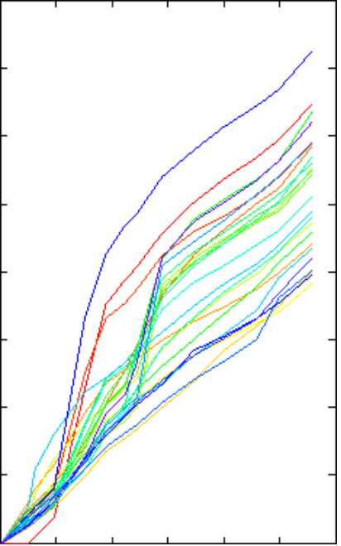

3500

3000

2500

2000

1500

1000

500

4000

3500

3000

2500

2000

1500

1000

500

0
0 2000 4000 6000

8000 10000 12000

0
0 2000 4000 6000

8000 10000 12000

Distance to stations (m) Distance to stations (m)
- (b)

4000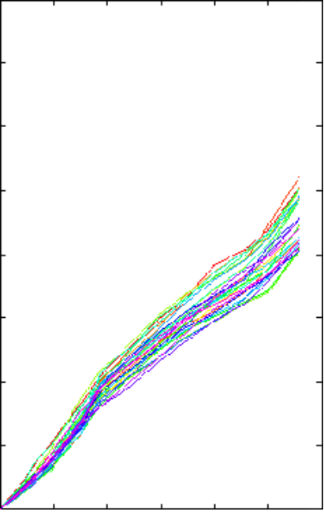

3500

3000

2500

2000

1500

1000

500
4000

3500

3000

2500

2000

1500

1000

500

0
0 2000 4000 6000

8000 10000 12000

0
0 2000 4000 6000

8000 10000 12000

Distance to stations (m) Distance to stations (m)
(c) (d)

FIGURE 1 Bus time–space diagrams: (a) travel time, December 8, 2005; (b) travel time clustered

4000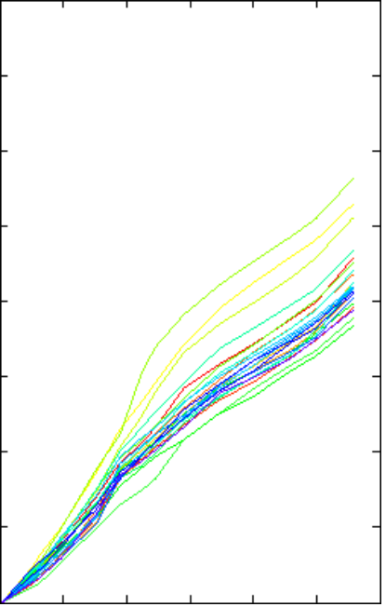

3500

3000

2500

2000

1500

1000

500
4000

3500

3000

2500

2000

1500

1000

500

0
0 2000 4000 6000

8000 10000 12000
0
0 2000 4000 6000

8000 10000 12000

Distance to stations (m) Distance to stations (m)
(e) (f)

FIGURE 1 (continued) Bus time–space diagrams: (e) travel time, April 4, 2006; and (f ) travel time clustered by time period, April 4, 2006.

how fast the bus will travel over the distance to the station of inter- est. Furthermore, this method would predict a nonzero speed even when v_{r} ? 0.
This model could therefore perform poorly in applications where the bus speed changes frequently, the GPS speed is not sufficiently
T ? Si ? t vi

where

i?1
- ti?2
? ... ? t
i?n ? td
(5)

accurate, or the historical average speed of the route does not ade- quately reflect the current speed of the traffic. As a result, this paper proposed a new scheme for predicting arrival time to a downstream stop. The proposed method first estimates the average travel speed to the immediate downstream route segments, denoted by i, based an average speed estimate updated dynamically as follows:
S_{i} ? distance from the current bus location to the end of route
segment i;
t_{i?n} ? travel time of each segment, estimated based on the average travel speeds of individual route segments in current period;
n ? number of route segments before reaching the station of
interest; and
t_{d} ? sum of average dwell time at each bus station that the bus will

v ? avr ? bvai ^{i} a ? b

where
(3)
pass by, which could be estimated on the basis of historical dwell time data for different time of day.
It is more reasonable for the proposed algorithm to develop a pre- diction model based on the average speeds of route segments rather

v_{i} ? predicted speed of route segment i (to the immediate downstream route segments),
v_{r} ? current speed of bus derived from GPS data,
v_{ai} ? historical average speed of route segment i in current time period, and
a,b ? weighting factors defined in Equation 4.
than the historical average velocity. It also leads to a superior result, because this model only estimates the speed to the end of the route segment instead of the speed to downstream bus stations, when the bus is far from the station.

INTELLIGENT SYSTEM FOR PREDICTING

a ? Sif
b ? Sib
(4)

BUS ARRIVAL TIME

where S_{if} is the distance from the current bus location to the end of the route segment i, and S_{ib} is the distance from the beginning of the route segment i to the current bus location. Based on Equations 3 and 4, the bus arrival time to downstream stations can be calculated as shown in Equation 5.
In order to predict the arrival time, the bus’s running direction must first be determined. In many existing studies, this issue is circum- vented by assuming that bus running direction can be derived from bus schedule and consecutive GPS data. However, in a real appli- cation environment, a bus could turn around in the middle of a trip and GPS data could give erroneous indication of bus travel direc- tion due to the well-known “backward data” problem (10). Wrong estimation on running direction could lead to totally incorrect pre- diction of arrival times. As a result, a bus arrival time prediction system is required to identify the running route and direction auto- matically, respond to unexpected incidents in time, and predict the expected arrival times for all the buses in service. To meet these requirements, this research proposed an intelligent prediction system based on the concept of finite state machine (also known as finite state automata). A system of finite state machine, denoted by M, is defined as follows:

state, ?) equals an unknown state. The unknown state represents the situation in which the system is disrupted by unexpected events such as missing GPS data, map-matching failure, and vehi- cle breakdown. Under the unknown state, the system would try to return to the beginning state through initialization.

CASE STUDY
The proposed arrival time prediction system was implemented on a trunk bus route (Route 871), passing through one of the busiest dis- tricts in the city of Chongqing, China, as shown in Figure 5. The route

M ? ?Q, ?, ?, q₀ , F ?
where
Q ? finite state set, ?q ? Q;
? ? input data;
? ? transition function, ? : Q ? ? ? Q; q₀ ? initial state, q₀ ? Q; and
F ? final state set, F ? Q.
(6)
includes a total of 14 bus stations, inbound from BaShan Station to Guan Yinyan Station and outbound from Guan Yinyan Station to BaShan Station, with a total distance of 22.8 km. The interstation distances are given in Table 1.
A total of 50 buses operated on this route, of which 36 are equipped with GPS receivers. The transit operated at a head of 10 min with a cycle time of 80 min. Two weeks of GPS data were collected with each day operating from 8:00 a.m. to 7:30 p.m. The GPS data were logged every 26 s, including device ID, time, longitude, latitude, and

At any point of time, the system could be in one of the four states, namely, Q equals {beginning state, prediction state (F), terminus state, unknown state (q₀)}. The relationship among the four states is shown in Figure 2. In the beginning state, the system would try to identify the route that a bus is currently servicing and the direc-
speed. The proposed system was set up in such a way so that it would predict bus arrival time whenever the system receives the GPS data. The performance of the prediction algorithm is evaluated using mean absolute percentage error (MAPE), defined as

tion that it is traveling. The underlying procedures are shown in Fig- 1 n

ures 3 and 4, respectively. If there is no incident, ? (beginning state, beginning state is normal) equals prediction state; otherwise, ? (beginning state, unexpected incident occurs) equals an unknown state. When the system is in the prediction state, it would contin-
MAPE ? ?
i o

where
? 100%

ually update its prediction on arrival times at the downstream sta- tions unless an unexpected incident has occurred, which would lead the system into the unknown state. When a bus reaches the terminus of its servicing route, it enters the terminus state, which could be returning to garage or getting ready for the next trip. The terminus state is included to ensure that the system would go into the unknown state directly after processing, namely, ? (terminus
t_{i} ? predicted arrival time,
t_{o} ? observed true arrival time, and
n ? number of predictions.
To predict bus arrival time, the GPS positions of the buses were first matched to the route and then used to calculate the distances from the current location of these buses to their downstream bus stations,

FIGURE 2 The four states of the proposed intelligent system for predicting bus arrival time.

FIGURE 3 Algorithm for determining bus route.

FIGURE 4 Algorithm for determining bus running direction.

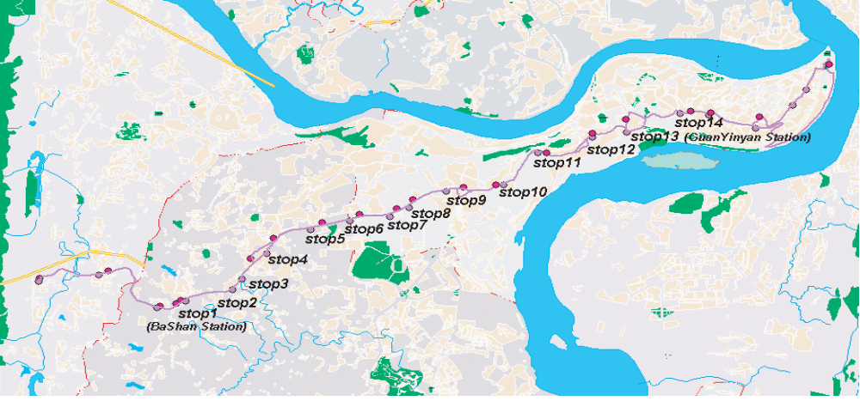

FIGURE 5 Layout of Bus Route 871 in Chongqing, China.

as described previously. The test results showed that the maximal absolute estimation error was less than 5%.
This research also compared the performance of the proposed algorithm with the algorithm proposed by Li et al. (9) in terms of prediction accuracy. Figure 6 shows the estimated arrival times by the two algorithms along with the actual arrival times as well as the corresponding estimation errors. The results indicate that the proposed algorithm had much less average and maximum estimation errors com- pared with Li et al.’s algorithm. This performance improvement may

TABLE 1 Interstation Distance of Route 871

InboundOutboundDistanceDistanceBus Station(meters)Bus Station(meters)Stop 1 (BaShan Station)0Stop 1 (Guan Yinyan Station)0Stop 2993.2Stop 21,418.7Stop 3230.5Stop 3851.3Stop 4708.3Stop 41,107.2Stop 51,101.2Stop 51,310.4Stop 6729.5Stop 6646.6Stop 7711.3Stop 7978.1Stop 8423.0Stop 8352.8Stop 9871.2Stop 9741.3Stop 101,153.0Stop 10695.3Stop 111,075.7Stop 11985.6Stop 121,208.1Stop 12890.1Stop 13774.8Stop 13386.2Stop 14 (Guan1,182.8Stop 14 (BaShan1,109.6Yinyan Station)Station)
be attributed to timely detection of traffic congestion with continuous location information.
Table 2 gives the performance statistics of the proposed algorithm by time period. It can be observed that the average estimation error is the highest at the early morning period (8:30 to 9:30 a.m.) when the bus route was most congested. This is because variation in traf- fic conditions and thus speed increases as the level of congestion increases, which means travel times to downstream stations become less predictable.
Figure 7 shows the MAPE of the predicted arrival times at individ- ual bus stations for different time periods. As shown in the figure, there is a large variation in prediction accuracy with respect to time period and station. For example, the MAPE of arrival time at Station 13 was very high for all periods due to the combined effects of traffic lights and dwell time along the route segment leading to this station. For the same reason, the MAPE for the period from 10:30 to 11:30 a.m. was the smallest.
The performance of the bus arrival time prediction algorithm is also expected to change as the prediction horizon or the distance to the downstream station increases. To quantify this relationship, a total of 500 GPS readings, located between Station 1 and Station 2, were used. Figure 8 shows the MAPE as a function of the distance. Interestingly, while the absolute prediction error increases as the prediction horizon increases, the relative prediction error actually decreases as the leading time increases. The relative error levels off when the prediction horizon exceeds 10 min.
Lastly, this research evaluated the performance of the proposed intelligent prediction system in terms of route determining and direc- tion detection. Two GPS-equipped buses were tested with runs involv- ing many direction changes, and the results are summarized in Table 3. The prediction system was perfect in detecting travel direction and had a success rate of over 98% in matching the service route. The route matching errors are expected due to possible errors in GPS loca- tion data and inaccuracy of the transit network model. These matching errors can be reduced by using higher-quality GPS receivers and more accurate digital street maps.

350

300

250

200

150

100

50

0
0 5 10

15
Samples of GPS

20 25

150

100

50

0

-50

-100
0 5 10 15 20 25
Samples of GPS

FIGURE 6 Performance of the proposed algorithm for bus arrival time prediction.

TABLE 2 Performance of Bus Arrival Time Prediction by Time of Day

8:30 –9:30 a.m.9:30 –10:30 a.m.10:30 –11:30 a.m.11:30 a.m.–12:30 p.m.Number of samples1,1819181,113516Maximal error (s)186110152170Minimal error (s)0000Average error (s)13.210.09.110.2MAPE (%)19.0715.0613.7615.69

35

30

25

20

15

10

5

0
1 2 3 4 5
6 7 8
9 10
11 12 13 14

FIGURE 7 Prediction error by bus station.

2000

1800

1600

1400

1200

1000

800

600

400

200

0
2 4 6 8 10 12 14
No. of downstream bus station

30

25

20

15

10

5

0
2 4 6 8 10 12 14
No. of downstream bus station

FIGURE 8 Prediction error by length of prediction.

TABLE 3 Performance of the Proposed System for Detecting Service Route and Running Direction

Rate of
Rate of Successful Number Number of Successful Detection of of GPS Successful Route Running

CONCLUSIONS
Accurate prediction of bus arrival time can not only help passengers time their departure times from work places and homes and make successful transfers by reducing waiting times at stops, but also help transit agencies manage and operate their systems in a more respon- sive manner such as real-time dispatching and scheduling. This paper has presented an algorithm for real-time prediction of bus arrival time, which has been implemented in an intelligent prediction system. The system is capable of tracking a large number of buses simultane- ously, detecting their service routes and directions automatically, and predicting their arrival time to downstream stations with an acceptable accuracy.

